**Fundamentos de los computadores**

**Practica** **2:** Álgebra de Boole

1.

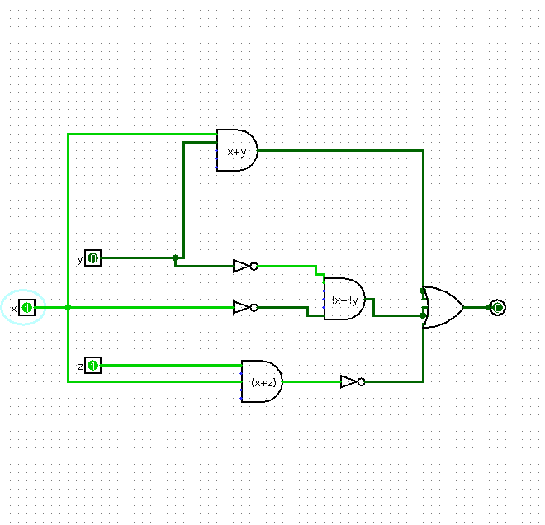

*Archivo ej1.circ*

2.

Simplificamos la siguiente expresión*: $f=\left[a\overline{b}\left(c+bd\right)+\overline{a}\overline{b}\right]c$*

$$f=\left[a\overline{b}c+\overline{a}\overline{b}\right]c$$

$$f=a\overline{b}c+\overline{a}\overline{b}c$$

$$f=\overline{b}c$$

Tabla de verdad para $f=\left[a\overline{b}\left(c+bd\right)+\overline{a}\overline{b}\right]c$

|  |  |  |  |  |
| --- | --- | --- | --- | --- |
| ***a*** | ***b*** | ***c*** | ***d*** | ***S*** |
| 0 | 0 | 0 | 0 | 0 |
| 0 | 0 | 0 | 1 | 0 |
| 0 | 0 | 1 | 0 | **1** |
| 0 | 0 | 1 | 1 | **1** |
| 0 | 1 | 0 | 0 | 0 |
| 0 | 1 | 0 | 1 | 0 |
| 0 | 1 | 1 | 0 | 0 |
| 0 | 1 | 1 | 1 | 0 |
| 1 | 0 | 0 | 0 | 0 |
| 1 | 0 | 0 | 1 | 0 |
| 1 | 0 | 1 | 0 | **1** |
| 1 | 0 | 1 | 1 | **1** |
| 1 | 1 | 0 | 0 | 0 |
| 1 | 1 | 0 | 1 | 0 |
| 1 | 1 | 1 | 0 | 0 |
| 1 | 1 | 1 | 1 | 0 |

Tabla de verdad para $f=\overline{b}c$

|  |  |  |
| --- | --- | --- |
| ***b*** | ***c*** | ***S*** |
| 0 | 0 | 0 |
| 0 | 1 | **1** |
| 1 | 0 | 0 |
| 1 | 1 | 0 |

3.

a) f(a,b,c,d)= 4∑ (0,2,4,5,6,8,10,11,12,13,14)

f(a,b,c,d)=4∏ (1,3,7,9,15)

b)

ab\cd 00 01 11 10

00 1 1 0 1

01 1 1 0 1

11 1 1 0 1

10 1 1 1 1

f= !c + c!d + a!bcd

a b c d S

0 0 0 0 1

0 0 0 1 1

0 0 1 0 1

0 0 1 1 0

0 1 0 0 1

0 1 0 1 1

0 1 1 0 1

0 1 1 1 0

1 0 0 0

f=!c+!d+!b

c b d S  
0 0 0 1

0 0 1 1

0 1 0 1

0 1 1

Ab\cd 00 01 11 10

00 1 0 0 1

01 1 1 0 1

11 1 1 0 1

10 1 0 1 1

Fs= a!bc + b!c + a!d + !a!d

$$f\sum{4} =a\overline{b}c + \overline{b}\overline{c}+a\overline{d} + \overline{a}\overline{d}$$

Fp= (a+!c+!d)(!b+!c+!d)(b+c+!d)

$$f\prod{4=(a+\overline{c}+\overline{d})(\overline{b}+\overline{c}+\overline{d})(b+c+\overline{d})}$$

4)

Ab\cd 00 01 11 10

00 1 0 1 0

01 1 0 0 0

11 0 1 0 0

10 1 0 1 1

Fs=!a!c!d+!b!c!d+a!bc+!bcd+ab!cd

4b)

A b c d S

0 0 0 0 1

0 0 0 1 0

0 0 1 0 0

0 0 1 1 1

0 1 0 0 1

0 1 0 1 0

0 1 1 0 0

0 1 1 1 0

1 0 0 0 1

1 0 0 1 0

1 0 1 0 1

1 0 1 1 1

1 1 0 0 0

1 1 0 1 1

1 1 1 0 0

1 1 1 1 0

4c)

A b c d S

0 0 0 0 1

0 0 0 1 0

0 0 1 0 0

0 0 1 1 1

0 1 0 0 1

0 1 0 1 0

0 1 1 0 0

0 1 1 1 0

1 0 0 0 1

1 0 0 1 0

1 0 1 0 1

1 0 1 1 1

1 1 0 0 0

1 1 0 1 1

1 1 1 0 0

1 1 1 1 0

5)

A b c d E

0 0 0 0 0 0

0 0 0 0 1 1

0 0 0 1 0 X

0 0 0 1 1 0

0 0 1 0 0 1

0 0 1 0 1 0

0 0 1 1 0 1

0 0 1 1 1 1

0 1 0 0 0 1

0 1 0 0 1 1

0 1 0 1 0 0

0 1 0 1 1 1

0 1 1 0 0 0

0 1 1 0 1 X

0 1 1 1 0 1

0 1 1 1 1 X

1 0 0 0 0 0

1 0 0 0 1 1

1 0 0 1 0 X

1 0 0 1 1 0

1 0 1 0 0 1

1 0 1 0 1 0

1 0 1 1 0 1

1 0 1 1 1 1

1 1 0 0 0 X

1 1 0 0 1 1

1 1 0 1 0 0

1 1 0 1 1 0

1 1 1 0 0 0

1 1 1 0 1 0

1 1 1 1 0 1

1 1 1 1 1 1

Ab\cde 000 001 011 010 110 111 101 100

00 0 1 0 x 1 1 0 1

01 1 1 1 0 1 x x 0

11 x 1 0 0 1 1 0 0

10 0 1 0 x 1 1 0 1

F=!c!de+b!c!d+!ab!ce+cd+!bc!e